Question:
Find the root of the equation using Regula Falsi Method using Python.
Aim:
Write a Python program to demonstrate to find the root of the equation using Regula Falsi Method.
Program:
import math
# Evaluate the user-defined function safely
def f(x, func_str):
try:
return eval(func_str, {"x": x, "math": math, "__builtins__": None})
except Exception as e:
print("Error evaluating function:", e)
return None

# Regula Falsi Method
def regula_falsi(func_str, a, b, tol):
fa = f(a, func_str)
fb = f(b, func_str)

if fa * fb >= 0:
print("Invalid interval. f(a) and f(b) must have opposite signs.")
return

print("\nIter\t a\t b\t f(a)\t f(b)\t Xr\t f(Xr)")
iter = 1
Xr_old = a # Initial guess to calculate error if needed

while True:
fa = f(a, func_str)
fb = f(b, func_str)

# Regula Falsi formula
Xr = (a * fb - b * fa) / (fb - fa)
fxr = f(Xr, func_str)

print(f"{iter:>3}\t{a:.4f}\t{b:.4f}\t{fa:.4f}\t{fb:.4f}\t{Xr:.4f}\t{fxr:.4f}")

if abs(fxr) < tol:
break

if fa * fxr < 0:
b = Xr
else:
a = Xr

iter += 1

print(f"\nApproximate root = {Xr:.4f} (correct to 3 decimal places)")

# === Main Program ===
print("=== Regula Falsi Method ===")
func_str = input("Enter the function f(x): ") # Example: x**3 - 4*x + 1
a = float(input("Enter the starting value a: ")) # Example: 0
b = float(input("Enter the ending value b: ")) # Example: 1
tol = 0.00004 # 3 decimal place accuracy

regula_falsi(func_str, a, b, tol)
Result:
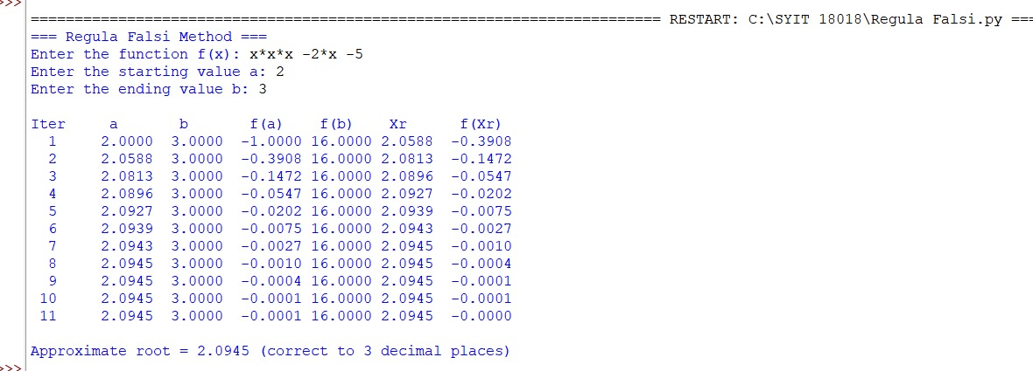

Conclusion:
The above Python program has been executed successfully.

